Food surplus and
waste reporting template
Please see the UK Guidelines for further information on completing this template.
Company name:
Name of person completing the report: Date completed:
Summary
Reporting period (start date – end date):
Overall food waste in tonnes:
Food waste as a % of the product and ingredient handled by your organisation*:
(Optional) Percentage of inedible parts included in total food waste tonnage:
* this should be tonnes food waste ÷ tonnes (food product produced or sold as intended + food waste + food sent to other destinations).
If food tonnes cannot be measured, provide an alternative metric, such as % by value, and explain the method used.

Destinations for food waste (tonnes or %)*: | Quantity | Unit
Anaerobic digestion / co-digestion
Composting / aerobic processes
Incineration / controlled combustion
Land application
Landfill
Sewer / wastewater treatment
Not harvested / ploughed in
Other (including unmanaged disposal)
Not known
* NB – the Dairy Processing Sector Guidance recommends reporting in both tonnes AND milk-equivalent

Other destinations (tonnes): | Quantity | Unit
Redistribution for human consumption*
Animal feed
Bio-based materials / biochemical processing
Not known
* It is important only to include here food that would have become waste if it had not been redistributed. Other donations to charities or sale to secondary markets should be excluded

Scope of the food waste inventory
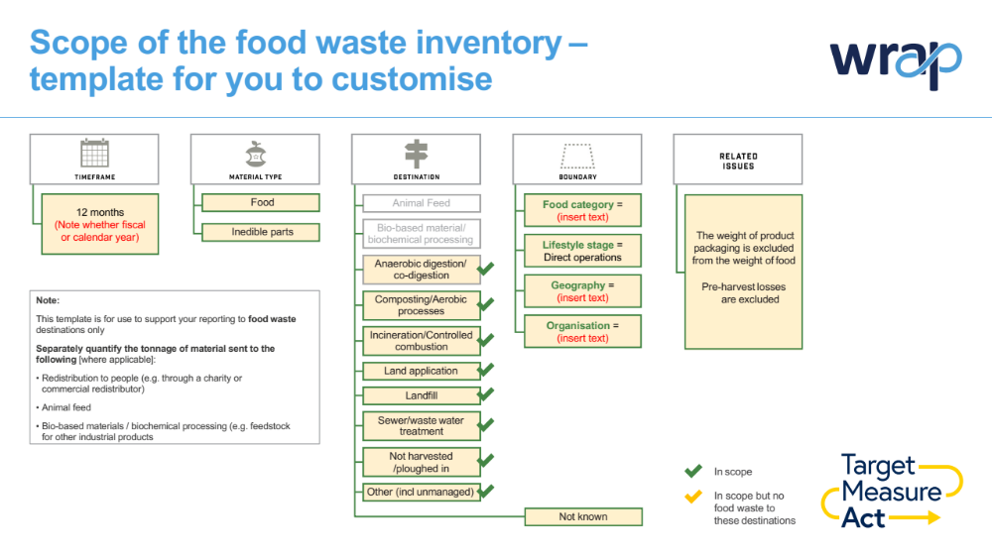
Quantification methods and uncertainty
Please describe quantification method(s) used – including:
- any sources of guidance, or published data sources used;
- methodological aspects, such as accounting for water addition/removal;
- any other points to clarify your summary and scope diagram
- the approach used and calculations used for any data sampling, scaling or gap filling;
- reasons for any data exclusions; and
- a qualitative description and/or quantitative assessment of the uncertainty around food waste inventory results
Assurance and declaration

Please tick this box to confirm that this report is based on the Food Loss and Waste Accounting Standard principles of Relevance, Completeness, Consistency, Transparency and Accuracy.

If assurance of the food surplus and waste data is undertaken (which may include peer review, verification, validation, quality assurance, quality control, and audit), provide an assurance statement and description.

Narrative (optional)
Use this section to describe any of the following:
- Your food waste hotspots (e.g. compositional split of food waste tonnage by product type)
- Actions that you are taking to reduce your operational food waste
- Progress to date – e.g. if you are tracking food waste over time, what progress have you made, are there any factors that have significantly affected your results (e.g. changes in supply and demand, new data / re-baselining), etc.
- Actions taken to work in partnership with suppliers to reduce food waste (e.g. number of whole chain Food Waste Reduction Plans in place)
- How you have engaged consumers to reduce food waste (e.g. adopting know best practices for food date labelling and storage advice; helping test new innovations; awareness raising)

